WEEK12

1. Abinarynumberisacombinationof1s and 0s.Itsnthleastsignificantdigitis thenthdigit starting from the right starting with 1. Given a decimal number, convert it to binary and determine the value of the the 4thleast significant digit.

# Example:

number=23

* + Convert thedecimal number23tobinarynumber:2310=24+22+21+20 = (10111)2.
  + Thevalueofthe4thindexfromtherightinthebinaryrepresentationis0.

# FunctionDescription

CompletethefunctionfourthBitintheeditorbelow. fourthBit has the following parameter(s):

intnumber:adecimalinteger Returns:

int:aninteger0or1matchingthe 4thleast significantdigitinthebinaryrepresentationof number.

# Constraints

0≤number<231

# InputFormatforCustomTesting

Inputfromstdinwillbeprocessedasfollowsandpassedto thefunction. The only line contains an integer, number.

# SampleCase0

**SampleInput0**

STDINFunction

32→number=32

# SampleOutput0

0

# Explanation0

* + Convertthedecimalnumber32tobinarynumber:3210=(100000)2.
  + Thevalueofthe4thindexfromtherightinthebinaryrepresentationis0.

# SampleCase1

**SampleInput1**

77→number= 77

# SampleOutput1

1

# Explanation1

* + Convertthedecimalnumber77tobinarynumber:7710=(1001101)2.
  + Thevalueofthe4thindexfromtherightinthebinaryrepresentationis1.

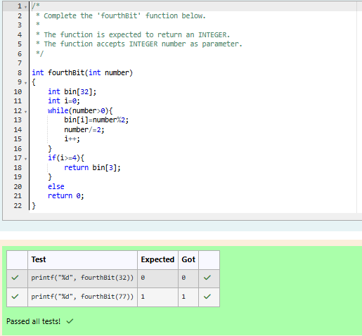

Q)Determinethefactorsof anumber(i.e.,allpositiveintegervaluesthatevenlydivideinto a number) and then return the pthelement of the list, sorted ascending. If there is no

pthelement,return 0.

# Example

n= 20

p= 3

Thefactors of20inascending orderare{1,2, 4, 5,10,20}.Using 1-basedindexing,ifp=3, then 4 is returned. If p > 6, 0 would be returned.

# FunctionDescription

CompletethefunctionpthFactorintheeditorbelow. pthFactor has the following parameter(s):

intn:theintegerwhosefactorsaretobefound int p:the index of the factor to be returned

Returns:

int:thelongintegervalueof thepthintegerfactorofnor,ifthereisnofactoratthatindex, then 0 is returned

# Constraints

1 ≤ n≤ 1015

1 ≤ p≤ 109

InputFormatforCustomTesting

Inputfromstdinwillbeprocessedasfollowsandpassedto thefunction. The first line contains an integer n, the number to factor.

Thesecondlinecontainsanintegerp,the1-basedindexofthefactortoreturn.

# SampleCase0

**SampleInput0**

10 →n= 10

3 →p= 3

# SampleOutput0

5

# Explanation0

Factoringn=10resultsin{1,2,5,10}.Returnthep=3rdfactor,5,astheanswer.

# SampleCase1

**SampleInput1**

STDIN Function

10 →n= 10

5 →p= 5

# SampleOutput1

0

# Explanation1

Factoringn=10resultsin {1,2,5,10}.Thereareonly4factors andp=5, therefore0is returned as the answer.

# SampleCase2

**SampleInput2**

1 →n= 1

1 →p= 1

# SampleOutput2

1

# Explanation2

Factoringn=1resultsin{1}.Thep=1stfactorof1isreturnedasthe answer.

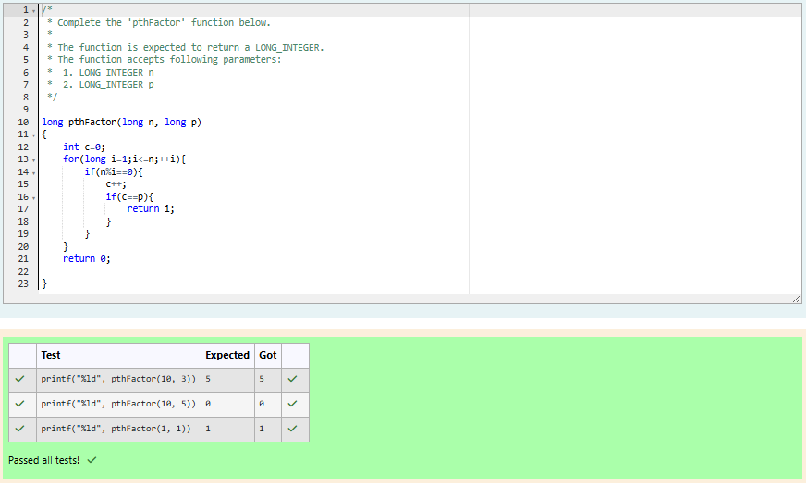

Q)Youarea bankaccounthacker.Initiallyyou have1rupeeinyouraccount, andyouwant exactly ***N*** rupees in your account. You wrote two hacks, first hack can multiply the amount of money you own by 10, while the second can multiply it by 20. These hacks can be used any number of time. Can you achieve the desired amount ***N*** using these hacks.

# Constraints:

1<=T<=100

1<=N<=10^12

# Input

* + Thetestcasecontainsa singleintegerN.

# Output

Foreachtestcase,printasinglelinecontaining thestring"1"ifyoucan makeexactlyN rupees or "0" otherwise.

SAMPLEINPUT 1

SAMPLEOUTPUT 1

SAMPLEINPUT 2

SAMPLEOUTPUT 0

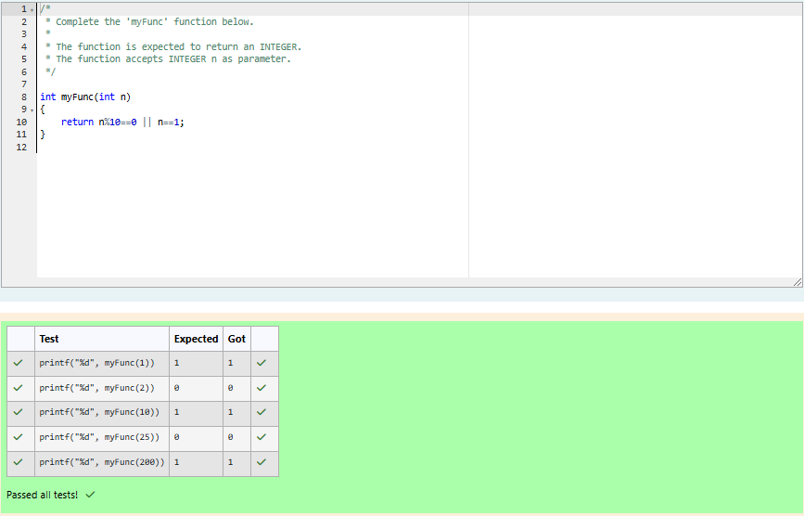

Q)Find thenumberofways that agiveninteger,***X***,canbeexpressedasthe sumof the ***Nth***powers of unique, natural numbers.

Forexample,if***X=13***and***N=2***,wehavetofindallcombinationsof uniquesquares adding up to ***13***. The only solution is 22+ 32.

# FunctionDescription

CompletethepowerSumfunctionintheeditor below.Itshouldreturnanintegerthat represents the number of possible combinations.

powerSumhasthefollowingparameter(s):

X:theintegertosum to

N:theintegerpowertoraisenumbersto Input Format

The first line contains an integer ***X***. Thesecondlinecontainsaninteger***N***.

# Constraints

***1 ≤X≤1000***

***2 ≤N≤10***

# OutputFormat

Outputasingleinteger,thenumberofpossiblecombinationscalculated.

# SampleInput0

10

2

# SampleOutput0

1

# Explanation0

If***X=10*** and***N=2***,weneedtofindthenumberofwaysthat ***10***canberepresentedasthe sum of squares of unique numbers.

***10 = 12+ 32***

Thisistheonlywayinwhich***10*** canbeexpressedasthesumofuniquesquares.

# SampleInput1

100

2

# SampleOutput1

3

# Explanation1

***100 =(102) =(62+ 82) =(12+32+42+52+72)***

# SampleInput2

100

3

SampleOutput2

1

# Explanation2

***100***canbeexpressedasthesumofthecubesof***1,2,3,4***.

***(1+8+27+64=100)***.Thereisnootherwaytoexpress***100***asthesumofcubes.

